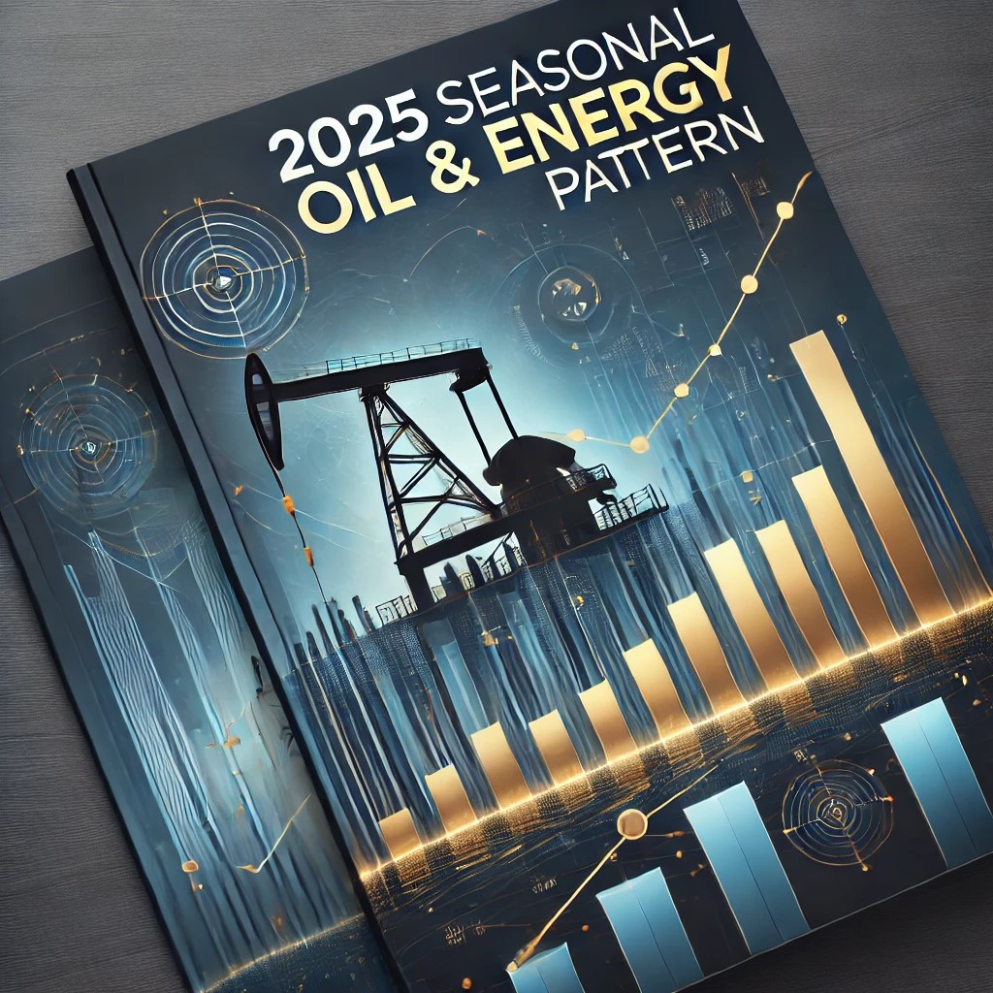

2025 Bullish Seasonal Pattern for Oil and Energy Report
© 2025 Tom Gentile
All content is owned or licensed by Tom Gentile and protected by intellectual property laws. Unauthorized reproduction, distribution, or use of this material is strictly prohibited.

Disclaimer
Just a heads-up: I'm not a registered Securities Dealer, Broker, or Investment Adviser in the U.S. or anywhere else. Everything in this report is for educational purposes only—not personalized investment advice. Trading, especially with options and futures, carries risks, and past performance doesn’t guarantee future results. Always consult a professional before making any investment decisions.
For full disclaimers, check out:
https://www.tomgentile.com/legal_disc...
https://tomstradingroom.com/disclaime...
https://gulfportanalytics.com/privacy...
https://gulfportanalytics.com/terms-o...
https://gulfportanalytics.com/cookie-...
https://gulfportanalytics.com/dmca-po...
https://gulfportanalytics.com/billing/

Why You Should Read This Report

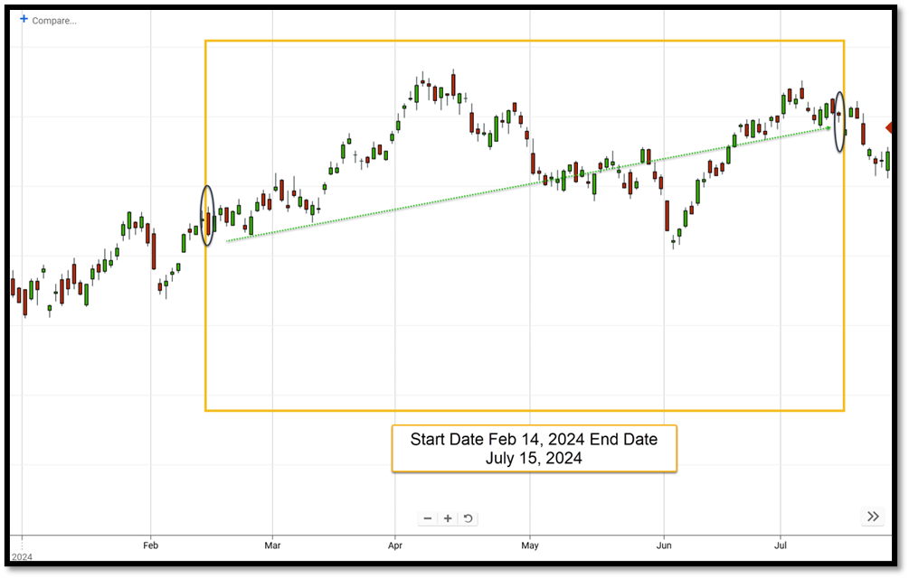
Imagine this: The United States Oil Fund (USO) jumps $7.08 per share between February 14 and July 15, 2024—a 9.6% return in just five months. That’s not just a one-time fluke; it’s part of a seasonal pattern. And in this report, I’ll break down this trend and the best way to profit before it ends.
The oil and energy market is one of the most influential industries in the world. It’s shaped by supply and demand, geopolitical events, and macroeconomic trends. By understanding recurring seasonal patterns, you can make smarter trading moves and position yourself for potential profits.
Whether you're a seasoned trader or just starting, this report will help you navigate the oil market and make informed decisions.
Let’s dive in…

Understanding the Seasonal Pattern in Oil

What Drives the Seasonal Surge in Oil Prices?
Between mid-February and mid-July, oil prices have historically risen due to several factors:
- Increased Summer Demand: Warmer months lead to more travel, increasing fuel consumption.
- Geopolitical Tensions: Many oil-producing regions experience political instability that can affect supply.
- Production Cycles: Refineries ramp up production in preparation for the peak summer driving season.
- Hurricane Season Disruptions: Supply chains can be affected by hurricanes, particularly in the Gulf of Mexico.
- OPEC Production Adjustments: The Organization of the Petroleum Exporting Countries (OPEC) often makes supply changes that influence prices.
By understanding these influences, traders can position themselves strategically for potential gains. (We’ll talk about two of my favorite strategies later in this report).

Historical Performance of USO During This Pattern
From 2007 to 2024, USO has experienced a bullish trend 72.2% of the time during this five-month window. That’s 13 out of 18 years showing positive returns. The average price increase over this period has been consistent, making it a compelling pattern for traders to leverage.

My Trading Strategies
My approach to options trading encompasses several styles, each tailored to different market conditions and opportunities:
- Momentum Trading: Capitalizing on securities that are trending strongly in one direction.
- Contrarian Trading: Taking positions against prevailing market sentiment, often during overbought or oversold conditions.
- Volatility Trading: Exploiting fluctuations in market volatility, often through strategies like straddles or strangles.
- Statistical Trading: Using quantitative analysis and historical data to identify high-probability trading opportunities.
- Seasonal Trading: Focusing on recurring patterns that occur during specific times of the year.
This report is primarily focused on seasonal trading—using historical trends to anticipate price movements. Unlike holiday seasonality, which is tied to calendar events, the patterns discussed here are driven by broader market dynamics, such as supply and demand cycles, geopolitical events, and macroeconomic trends.

My 3-Step Process for Trading Patterns



1. Spot the Opportunity
The first step is to identify a security that is likely to move in price. In the case of oil, the United States Oil Fund (USO) serves as an excellent proxy for the broader oil market. By analyzing historical data, I have identified a consistent bullish trend in USO from mid-February to mid-July.

2. Build an Acceptable-Risk Trade
Building a trade with an acceptable risk level is key. This includes:
- Choosing the right options strategy (long calls, debit spreads, etc.).
- Setting risk levels to protect against major market fluctuations.
- Selecting an expiration date that aligns with the seasonal trend.

3. Managing the Trade
A well-managed trade includes setting clear exit strategies. This includes setting realistic return on investment (ROI) goals, using stop-loss orders, and adjusting positions as market conditions change.

Breaking Down USO and This Seasonal Pattern

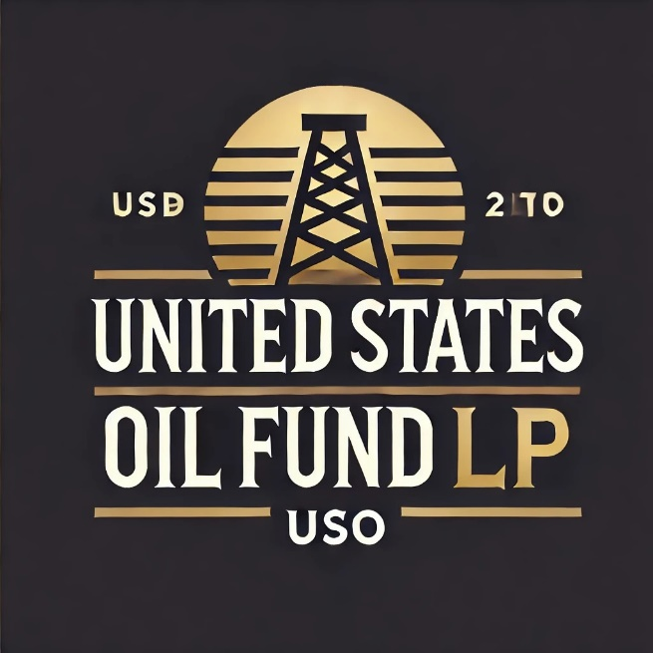
Instead of focusing on individual oil stocks, I use USO as a broad market indicator. Since its launch in 2006, USO has followed a bullish trend from mid-February to mid-July 72% of the time. That’s a strong historical precedent!
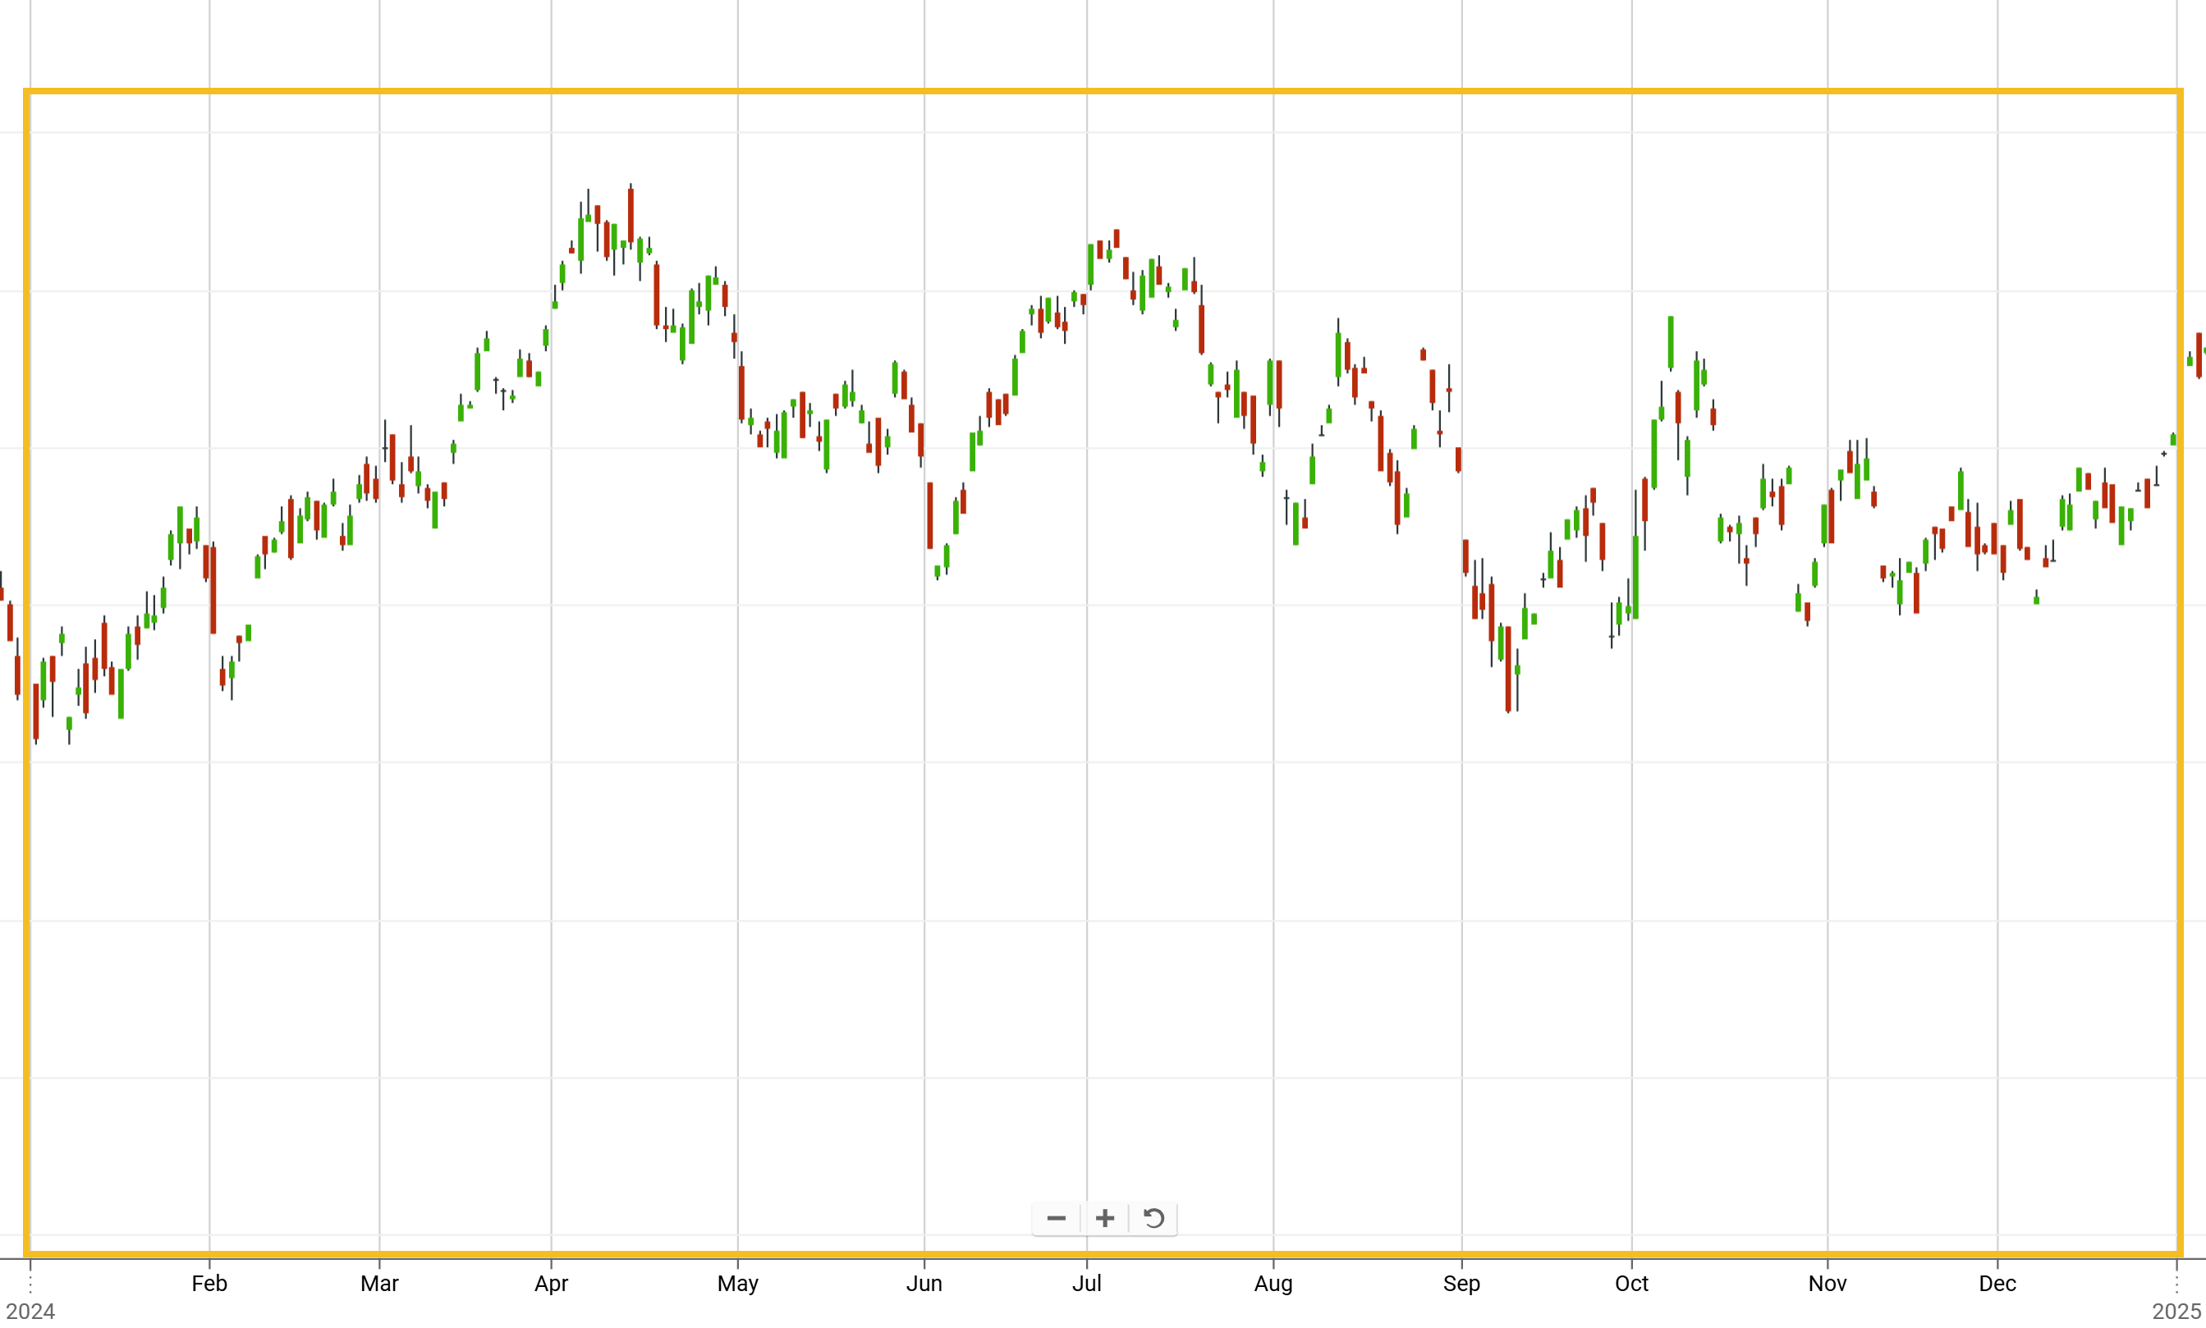
Why USO, you may be asking?
Easy! It’s designed to track crude oil prices, making it a more predictable instrument for seasonal trading compared to individual stocks.

Oil Sector Bullishness

Between 2007 to 2024, USO traded higher in 13 out of 18 years. That’s a 72.2%-win rate! This pattern is driven by a combination of factors, including increased demand during the summer driving season, geopolitical tensions, and supply constraints.

The following is a spreadsheet showing price data (open and closing price) for USO on the dates analyzed (sourced from www.tomsoptiontools.com):

Bullish Seasonal Data for USO 2007-2024

Oil Market Recap and 2025 Outlook

2024 Market Performance
USO gained about 4 points over the year. The first half was bullish, driven by tensions between Iran and Israel and Houthi attacks on oil shipping routes. However, the second half saw a decline due to increased production and lower demand from China.

2025 Forecast
With Donald Trump’s re-election, expect a pro-oil stance with policies favoring domestic energy production. The Energy Information Administration (EIA) forecasts Brent crude to average $74 per barrel in 2025, down from $81 in 2024. However, geopolitical tensions and supply chain disruptions could push prices higher.
For traders, this means volatility – and that could create significant trading opportunities!
And this is my secret weapon to do so…

The Money Calendar: A Powerful Trading Tool



What It Is
The Money Calendar is my proprietary tool that scans historical data to find recurring price patterns. It’s designed to help traders pinpoint high-probability setups.

How It Works
For example, the Money Calendar identified a 28-day pattern starting March 11, showing an average gain of 2.15% ($3.52 per share) for USO. But based on recent trends, the longer 5-month pattern from mid-February to mid-July has shown stronger results.
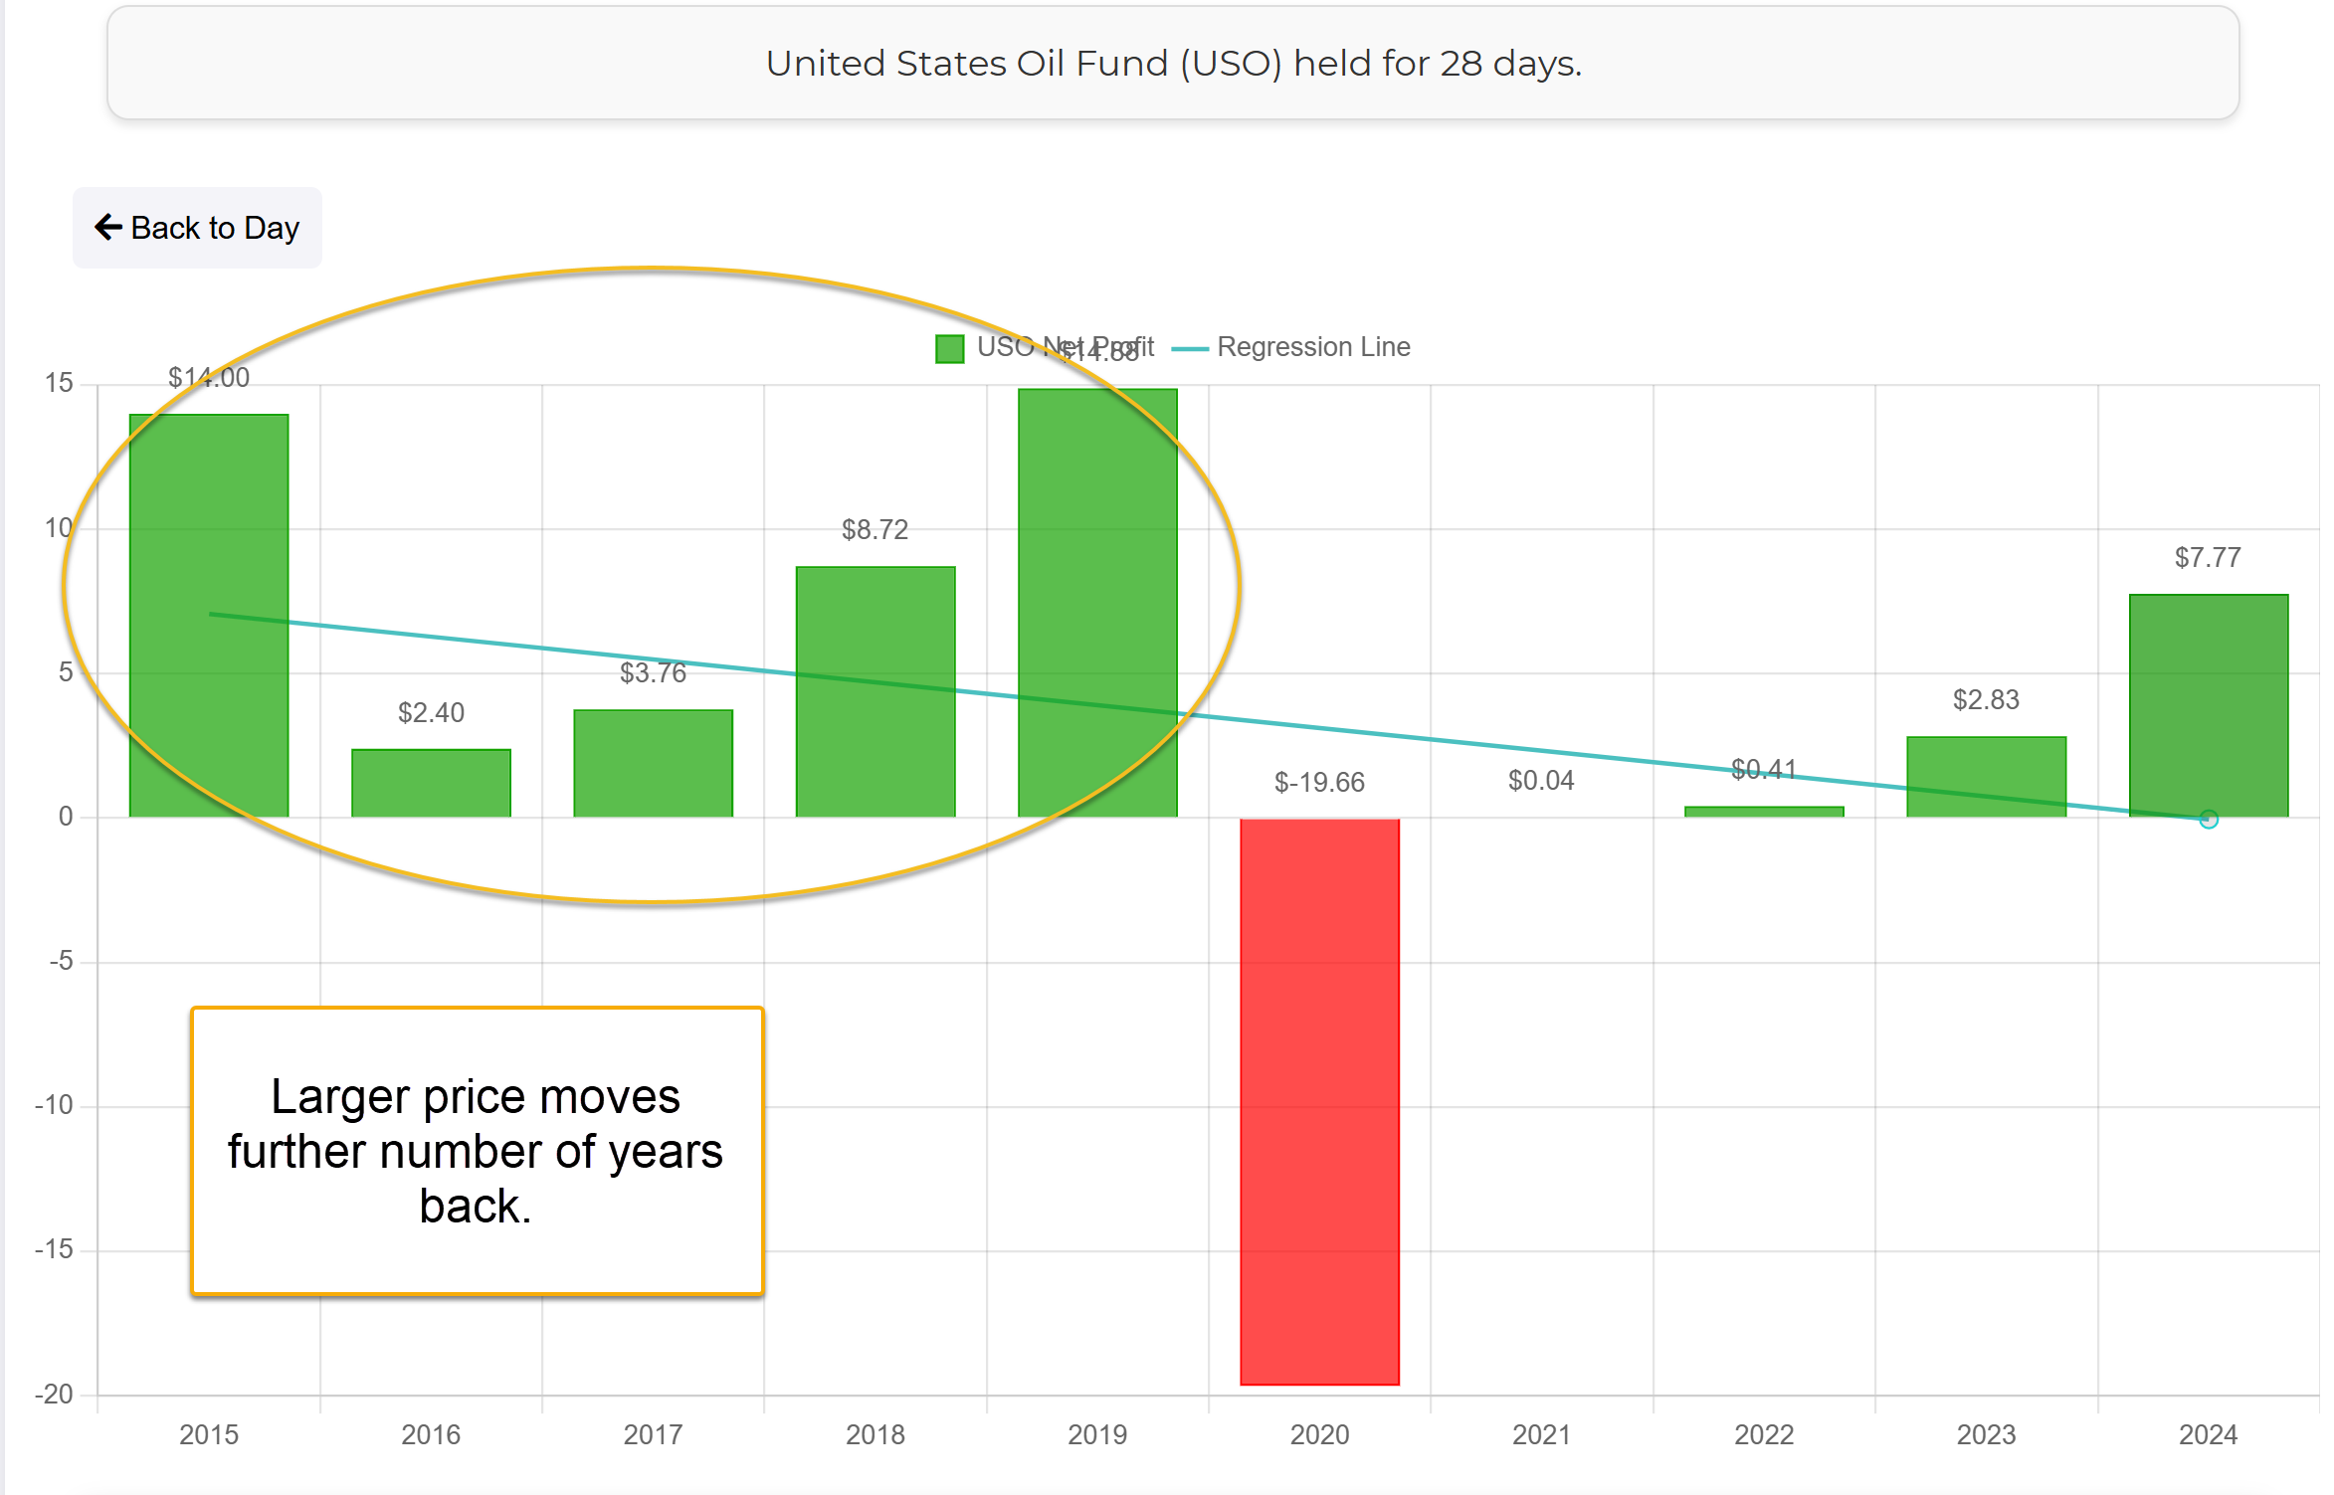
Two Profitable Options Strategies for This Trade
I leverage the power of options for their leverage. Options can provide a higher ROI compared to direct investment in securities, though they come with the risk of expiring worthless if not managed properly. That’s why I stick to my three-step trading approach – no matter what the markets are doing.
And when it comes to this oil and energy pattern, these are my two favorite option strategies to use:

1. Long Call
Buying a call option gives you the right to buy a security at a fixed price before expiration. If USO’s price goes up, you can profit significantly.

2. Call Debit Spread
This strategy involves buying a call at a lower strike price and selling one at a higher strike price. It limits risk while still allowing for solid returns.
Remember… the setups above are for educational purposes only and are NOT official recommendations. You should consult your broker or financial advisor before placing any trade. Summary
This report highlights a seasonal bullish trend in oil from mid-February to mid-July…
But it’s just one of MANY powerful strategies you can use to capitalize on repeatable patterns identified by the Money Calendar every single day.
Visit www.gulfportanalytics.com/products/timed-trader-pro learn how the Money Calendar can help you capitalize on high-probability trades and aim for 100% gains in 30 days or less.
Happy trading!
Tom Gentile
America’s Pattern Trader

